NSQ1 S24 Course Assignment 1

For this assignment, you should model an online bookstore based on the Book section of [Amazon (UK)](https://www.amazon.co.uk/gp/browse.html?node=266239&ref_=nav_em__bo_books_0_2_9_2). The model needs to be a relational model. You can add as much as you like, but you need at least the following:

## Books

See for yourself what you can find about a book in the store, but keep in mind that a bookstore has more copies of a book, and sometimes they are sold out.

## Category

The Amazon bookstore operates with categories to help browsing for books. You can see the categories in the following screen dump:

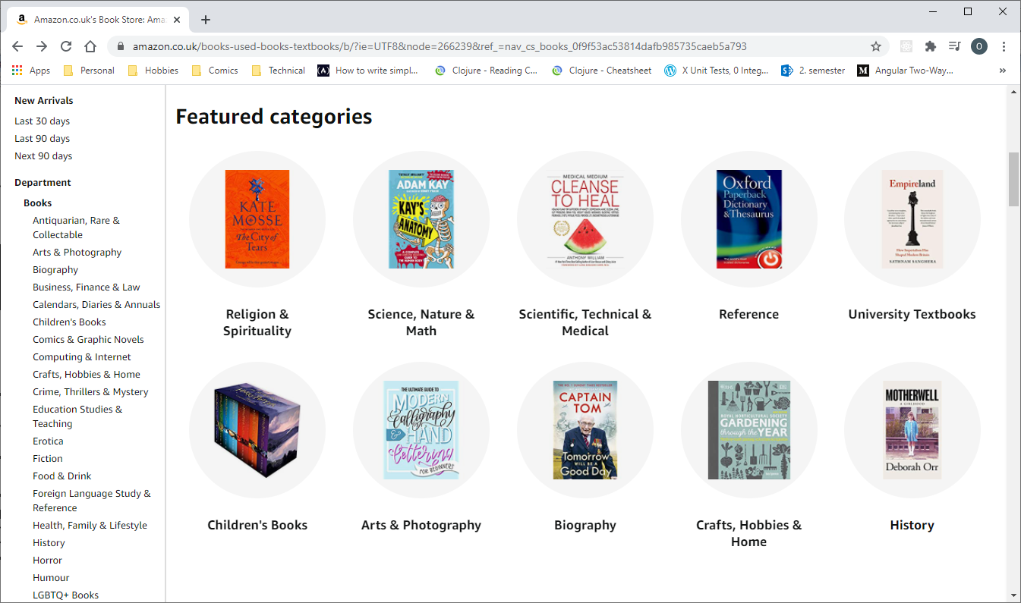

Categories

Note that the categories have subcategories, and that a book can belong to more than one category.

## Character and Genre

When you drill down into various categories (e.g. Fiction->Science Fiction or Fiction->Fantasy), you will find that some of them come with character types and genres. A book can have more character types and belong to more genres.

## Customer

If you cannot find out how Amazon registers customers, come up with your own ideas.

## Order

Orders need at least a unique identifier and a date. You should be able to order any number of books, including several copies of the same book.

# Question 1

Make an (E)ER model of the bookstore. Get as close to the actual bookstore as possible.

# Question 2

Map the model to the database. (Logical model)

# Question 3

Implement the model using SQL. Add some data to get a feel for how it works. It is recommended to follow the guidelines below.

* All tables should have data
* Most, if not all, data should be related to something
* The data should contain a hierarchy of categories
* Of course, add as much data as you need to test your answers to Question 4, below.

# Question 4

Answer the following questions in SQL using your model from previous questions.

## Modifying data

Use SQL to execute the following scenarios. If nothing else is stated, assume you know the ids of the entities involved.

1. Sell a book to a customer.
2. Change the address of a customer.
3. Add an existing author to a book.
4. Retire the "Space Opera" category and assign all books from that category to the parent category. Do not assume you know an id of the parent category.
5. Sell 3 copies of one book and 2 of another in a single order

## Querying data

Write SQL statements to return the following data

1. All books by an author
2. Total price of an order
3. Total sales to a customer
4. Books that are categorized as neither science fiction nor fantasy (**note:** A book can have more categories. Make sure you don’t return books that are fantasy romance, for instance.)
5. Average page count by genre
6. Categories that have no sub-categories
7. ISBN numbers of books with more than one author
8. ISBN numbers of books that sold at least X copies (you decide the value for X)
9. Number of copies of each book sold – unsold books should show as 0 sold copies.
10. Best-selling books: The top 10 selling books ordered in descending order by number of sales.
11. Best-selling genres: The top 3 selling genres ordered in descending order by number of sales.
12. **(Optional)** All science fiction books (Hint: Google "WITH RECURSIVE")
13. **(Optional)** Characters used in science fiction books
14. **(Optional)** Number of books in each category

**Note:** In the last three exercises, subcategories of science fiction also count as science fiction, so it’s not enough to just look for the science fiction category.

# Question 5

Write a report on the experience gained by completing Question 1 through 4 above. The report should contain answers to the questions

* What were the decisions taken in the modelling?
* Why were these decisions taken?
* What were the consequences of these decisions?
* What were the difficult and easy parts of the exercise?

# Rules

* Make the exercise in groups of 2 – 4
* Hand in to itslearning no later than 22 February if you want feedback

q4 ex 4